**Unveiling a Counterfeit Food Supplement Ring: Criminal Prosecution for a Korean Trademark Counterfeiting Case**

According to the National Steering Committee 389, the year 2023 witnessed an alarming increase in acts of counterfeit production, trade, and infringement of intellectual property rights (IPR). The number of cases recorded in 2023 was over 4,000, an increase of more than 126% compared to the same period in 2022. Notably, many cases have been handed over to the police for prosecution on charges related to counterfeit production, trade, and [IPR infringement](https://kenfoxlaw.com/handling-intellectual-property-rights-infringement-in-vietnam-which-measures-are-effective).

Developments in the market during the first six months of 2024 indicate that counterfeit goods are present in a wide range of sectors and industries, from food, pharmaceuticals, and cosmetics to electronics and fashion. Counterfeit goods are becoming increasingly sophisticated, making it nearly impossible to distinguish between genuine and counterfeit products with the naked eye. High profits are the driving force behind the production and sale of [counterfeit goods](https://kenfoxlaw.com/fighting-counterfeits-and-trademark-squatting-in-vietnam-a-perspective-from-foellie-case), with perpetrators disregarding consumer health and legal penalties.

KENFOX IP & Law Office provides information about a large-scale counterfeit food supplement production and distribution ring that was dismantled in April 2024.

**Case of Producing and Selling Counterfeit Goods**

In April 2024, Thanh Hoa City Police, in close coordination with relevant units, successfully dismantled a large-scale inter-provincial counterfeit food supplement ring.

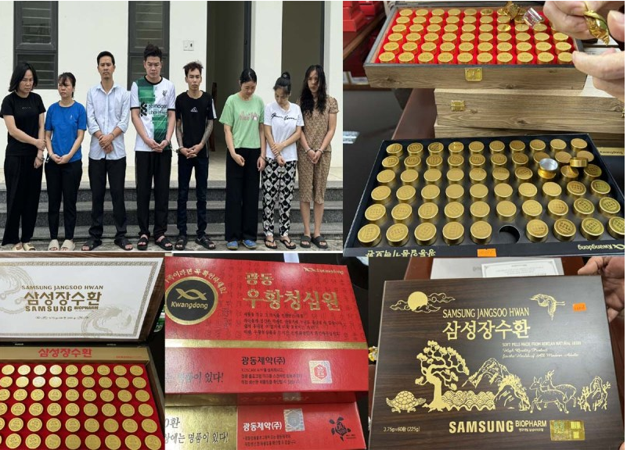

The ring was led by Nguyen Thi Thinh (born 1978), residing in My Dinh 2 ward, Nam Tu Liem district, Hanoi.

Having experience in the pharmaceutical and nutraceutical business, Thinh knew how to find sources of counterfeit goods and how to distribute them in the market. Taking advantage of her experience, Thinh ran a closed-loop, highly sophisticated operation to produce and sell counterfeit An Cung Nguu Hoang Hoan products of Kwangdong Corporation (Korea).

According to statistics from market research firm Intercontinental Marketing Services Health, by the end of 2018, over 82% of the Korean An Cung market share belonged to Vu Hoang Thanh Tam products of Kwangdong Pharmaceutical Group with revenue of around VND 630 billion

**Sophisticated Tactics: Evading Authorities**

Nguyen Thi Thinh chose food supplements that claimed to prevent stroke and improve brain function to exploit consumers' preference for imported goods, particularly the well-known Korean brand An Cung Ngưu Hoang Hoan. Taking advantage of the demand for cheap products, Thinh offered counterfeit products at lower prices than genuine ones to attract customers. To produce counterfeits, Thinh purchased imitation "pills" from the market, carefully studied the packaging, labels, and ingredients of the genuine product to produce counterfeits that were identical to the real product of Kwangdong Corporation. Thinh divided the shipments into smaller batches and assigned different stages of packaging and distribution. The packaging and storage locations were divided into different places to avoid detection by [authorities](https://kenfoxlaw.com/administrative-ipr-enforcement-authorities-of-vietnam). The products were then sold to small drugstore vendors, pharmacies, and retail channels through multiple intermediaries for distribution, making it difficult to trace the origin of the products.

To gain trust, Thinh visited Kwangdong Corporation's headquarters in Korea and live-streamed the visit on social media.

**Simultaneous Raids: Dismantling an Interprovincial Counterfeiting Ring**

After gathering sufficient evidence, Thanh Hoa City Police mobilized over 50 officers and soldiers to conduct simultaneous searches at 10 locations in Hanoi and Thanh Hoa City.

During the searches, the police seized over 4,000 boxes of finished Vu Hoang Thanh Tam An Cung Vien Hoan (10-tablet boxes), with a total value of approximately VND 10 billion, 100 boxes of An Cung Ngưu Hoang Hoan (60 tablets/box) manufactured by Samsung Pharm, 7 bags containing plastic bottles and caps, over 1,000 Kwangdong anti-counterfeit labels, Kwangdong instruction labels, over 1,000 kg of round yellow tablets, and various packaging tools and machinery.

The most significant challenge during the investigation was proving that the pharmacy owners and retailers were aware they were selling counterfeit goods. Despite this obstacle, the Thanh Hoa City Police's Criminal Investigation Department decided to [prosecute](https://kenfoxlaw.com/handling-ipr-infringement-under-criminal-route-in-vietnam-key-takeaways) the case, indict the suspects, and detain Nguyen Thi Thinh (ringleader), Nguyen Lan Huong (40 years old, residing in La Khe ward, Ha Dong district, Hanoi), Tran Anh Cuong (30 years old, residing in Trung Van ward, Nam Tu Liem district), Ngo Thi Tu (42 years old, residing in Hoang Liet ward, Hoang Mai district), Nong Quang Hai (33 years old, residing in My Dinh 1 ward, Nam Tu Liem district); Nhu Thi Minh (33 years old, residing in My Dinh 2 ward, Nam Tu Liem district); Pham Van Chien (39 years old, residing in Cong Vi ward, Ba Dinh district), and Trinh Thi Hiep (39 years old, residing in Phu Son ward, Thanh Hoa city) on charges of "Production and sale of counterfeit food." In this case, Hang was identified as the person hired by Nguyen Thi Thinh to package the finished counterfeit anti-stroke pills.

The suspects confessed that from the beginning of 2023 until their arrest, they had produced and sold over 20,000 boxes of counterfeit Vien Hoan Vu Hoang Thanh Tam, with a total value of approximately VND 50 billion.

**What Trademark Owners Should Do**

* Strengthen publicity and education to raise consumer awareness about the harms of counterfeit and pirated goods, and encourage consumers to use genuine products.
* [Register IPRs](https://kenfoxlaw.com/why-should-figurative-marks-and-product-labels-be-registered-as-copyright-in-vietnam) for trademarks and product packaging in accordance with the law to receive legal protection.
* Regularly monitor the market to detect and identify counterfeit products and IPR infringements early on, and take timely action to prevent losses.
* Upon discovering counterfeit products bearing their trademark, collect [evidence](https://kenfoxlaw.com/how-to-strategically-use-evidence-in-ip-infringement-cases-in-vietnam) to request enforcement agencies to handle the matter in accordance with the law. Evidence may include counterfeit products, purchase invoices, and evidence of counterfeit production and sales activities.
* Every year, agencies such as the Market Surveillance Authority and Customs of Vietnam organize conferences and workshops on IPR enforcement and protection. IPR owners can participate in these events to connect with government agencies, propose solutions, and call for increased IPR inspection, supervision, and enforcement.
* The application of science and technology also plays an important role in [combating counterfeiting](https://kenfoxlaw.com/the-drastic-rp7-anti-counterfeit-campaign-how-to-effectively-handle-intellectual-property-rights-infringements-in-vietnam). Using traceability codes, applying blockchain solutions to supply chain management, and so on can make counterfeit detection and handling more efficient.

**Final thoughts**

This case of counterfeit food supplement production and distribution has garnered significant public attention due to its large scale, sophisticated methods, and severe impact on the reputation, brand image, revenue, and market share of the trademark owner, Kwangdong Corporation. However, from another perspective, the case not only demonstrates the unwavering determination and efforts of enforcement agencies but also reaffirms a powerful message: Vietnam will not tolerate any acts of IPR infringement.

The close, flexible, and effective cooperation among law enforcement agencies, and the unwavering spirit of fighting against IPR crimes, are positive signals that reinforce the confidence of right holders in the IPR protection and enforcement mechanisms in Vietnam

With 15 years of experience, KENFOX IP & Law Office has successfully collaborated with Vietnamese enforcement agencies to investigate and handle numerous complex, sophisticated, and large-scale intellectual property (IP) infringement cases. Our team of experienced lawyers and intellectual property experts is dedicated to providing comprehensive and effective legal solutions to protect your valuable IP assets.