How do I find a Vietnam patent?
Search Patents in Vietnam
Search Patents in Vietnam

How to respond to a patent infringement allegation in Vietnam

Your invention cannot be patented if it has already been made public. Therefore, a search of all previous public disclosures, foreign patents and printed publications should be conducted.

Online Patent Register and Online Gazette in Vietnam

You can search for patents in Vietnam using the following three databases:

(i) Search # 1: http://iplib.ipvietnam.gov.vn/WebUI/WSearch.php

This Search #1 is the Intellectual Property Office of Vietnam's Online Register. Since March 2020, the database for this Search #1, which has been established and utilized for years, has ceased to be updated.

Please access http://iplib.ipvietnam.gov.vn/WebUI/WSearch.php to search patents in Vietnam.

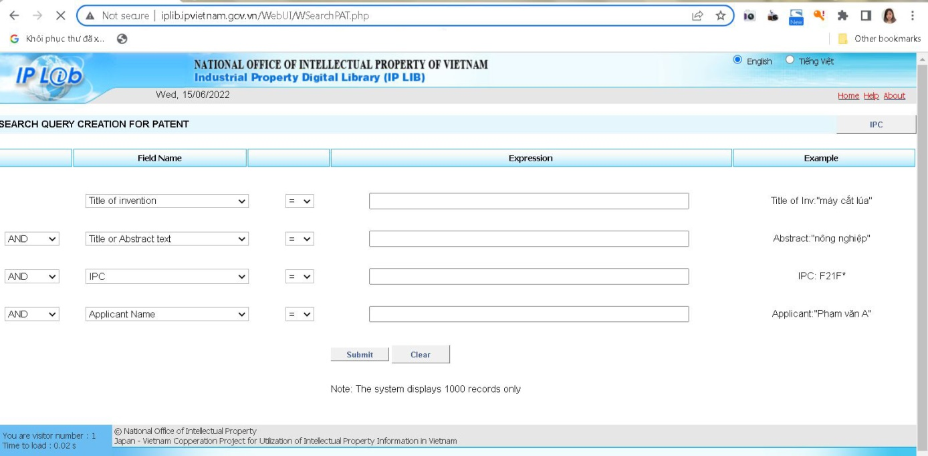

(ii) Search # 2: An online tool powered by WIPO

This online has been recently built as a result of mutual cooperation between the IP Office of Vietnam (IP Vietnam) and WIPO. Since February 2020, the application database has been regularly updated for Search #2 only. Search #2 provides the information of Vietnamese applications in a more detailed and systematic manner. It is well designed to facilitate the search of applications already filed in Vietnam.
The database of Search #2 is more complete and accurate. Therefore, you are recommended to use Search #2.

Please access http://wipopublish.ipvietnam.gov.vn/wopublish-search/public/home?1&lang=en to search patents in Vietnam.

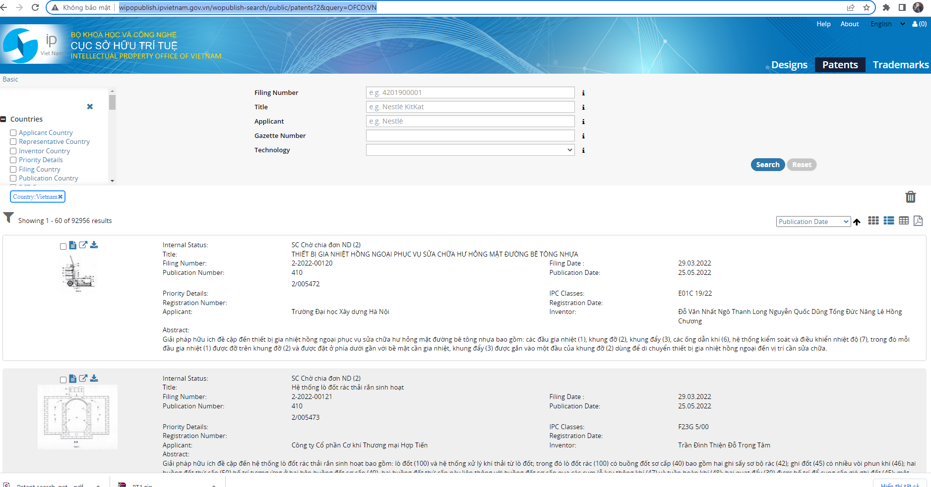
Search Patents in Vietnam

(iii) Search # 3: Online industrial property gazette of Vietnam

The online gazette is published monthly in Vietnamese. Its coverage is from 1982 to present.
Please access https://ipvietnam.gov.vn/web/guest/cong-bao-so-huu-cong-nghiep1 to search patents in Vietnam.

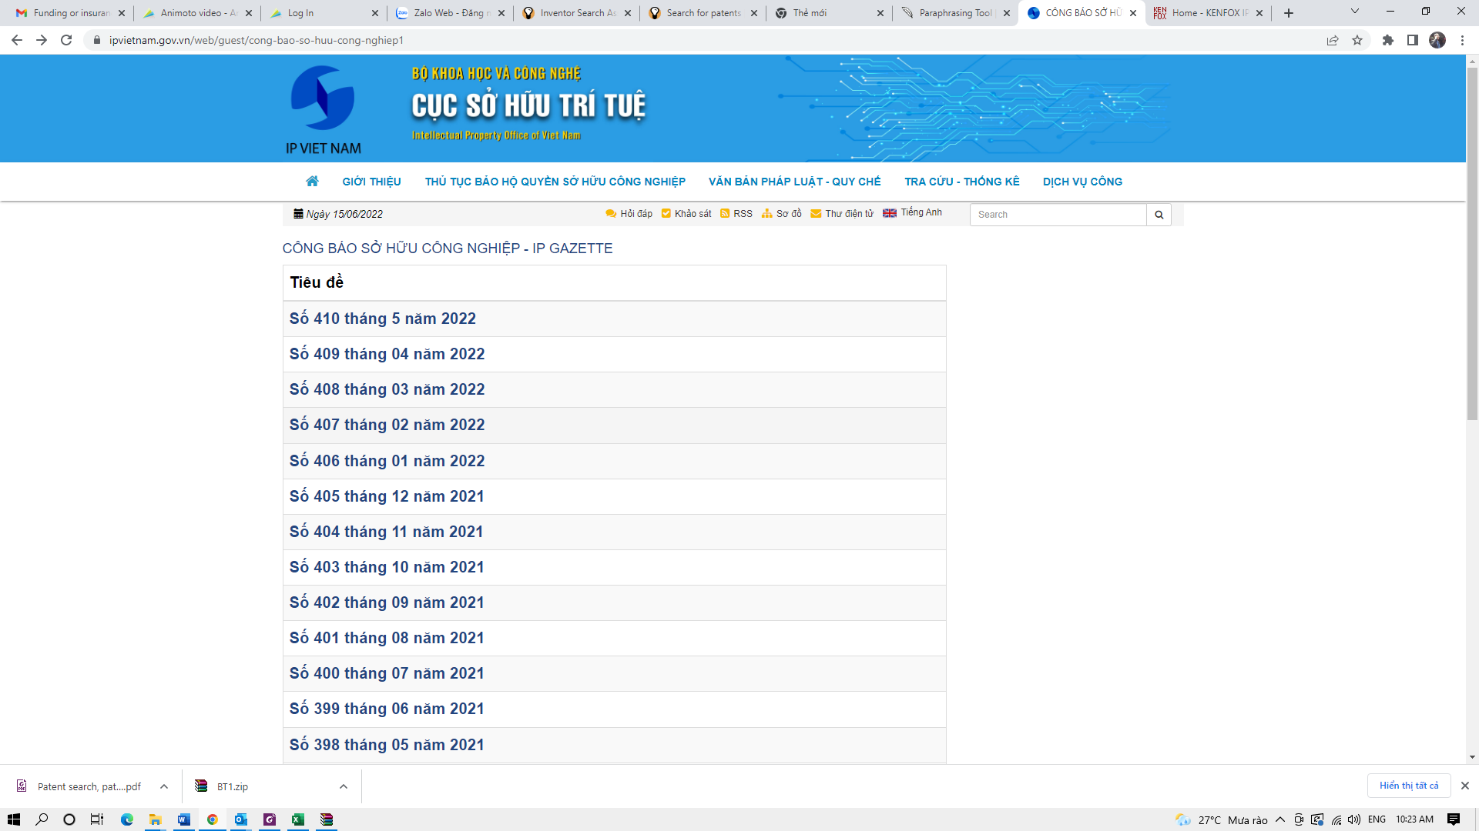

Additional notes:

- Viet Nam is also a member of the regional IP information platform ASEAN Patentscope. Thus, you may seach patents on the said platform. On ASEAN Patentscope, it is also possible to search for Vietnamese patents on an English interface by PCT Application/Publication Number, by Applicant/Inventor Name, and by Priority Data, and to retrieve information on Legal Status and PCT National Phase Entry.

- In addition to the above online searches, an additional search at http://digipat.noip.gov.vn/ can be utilised. The aforesaid web-based patent search serves as a digital library on Vietnamese patents to facilitate the search of patent information based on the database (including XML documents under WIPO Standard ST36 and PDF documents) converted from the results of a digitisation project. This provides updated information on Vietnamese patents only.
Search Patents in Vietnam
KENFOX IP & LAW OFFICE, one of the fastest growing patent law firms, provides the full range of IP services in Vietnam, Laos, Cambodia, Myanmar and other Asian countries. In 2019, KENFOX was listed in the Top 10 Patent Filers before the Intellectual Property Office of Vietnam (IP Vietnam). In 2020 and 2021, KENFOX was listed in the Top 20 Patent Filers before IP Vietnam. Please contact us if you are interested in IPR protection in the above-mentioned jurisdictions.

Contact
KENFOX IP & Law Office
Building No. 6, Lane 12/93, Chinh Kinh Street, Nhan Chinh Ward, Thanh Xuan District, Hanoi, Vietnam
Tel: +84 24 3724 5656
Email: info@kenfoxlaw.com / kenfox@kenfoxlaw.com

