**Intellectual property rights protection in Vietnam**

**Intellectual property rights protection in Vietnam**

**Mr. Nguyen Vu Quan - Member of KENFOX IP & Law Office Receives "Lexology Legal Influencer" Award for Two Consecutive Years**

KENFOX IP & Law Office is thrilled to announce that our esteemed member, [Mr. Nguyen Vu Quan](https://kenfoxlaw.com/professional_item/mr-nguyen-vu-quan), has been recognized as a "Lexology Legal Influencer Q2-2024" ("Q2-2024 Legal Industry Influencer") in the Intellectual Property (**IP**) field. This marks Mr. Quan's second consecutive recognition by Lexology, following his outstanding achievement in earning the "Lexology Legal Influencer Q2-2023" award last year. (see: <https://www.lexology.com/firms/kenfox-ip-and-law-office/nguyen_vu_quan>)

Mr. Quan's consecutive two-year win of the "Lexology Legal Influencer" award is a testament to his dedication and exceptional expertise in the IP field. With his in-depth knowledge, sharp strategic vision, extensive practical experience, and strong sense of responsibility, Mr. Quan is always striving to provide clients with optimal legal solutions, contributing to the protection and maximization of the value of their IP assets.

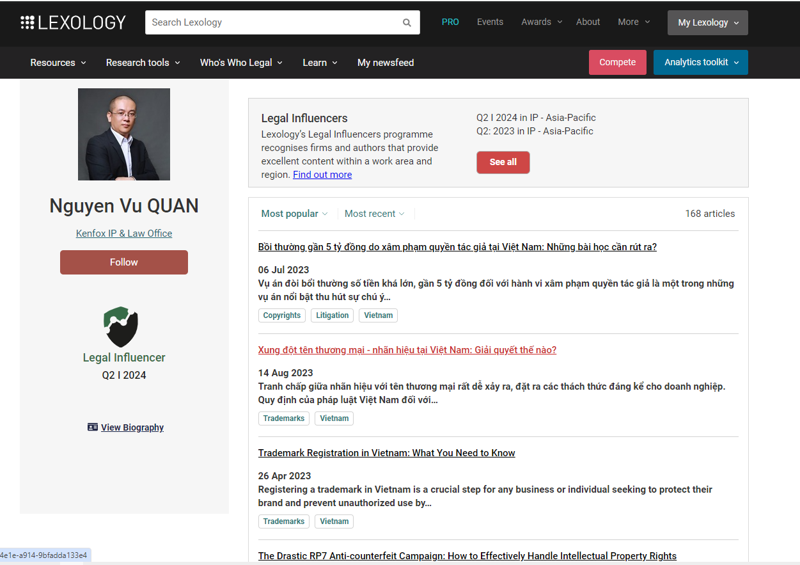

**Legal Influencer**

The "Legal Influencer" award recognizes individuals, leaders, lawyers, and experts whose articles have been widely read by legal professionals on the Lexology platform. These articles must provide insightful and practical legal analysis covering areas of specialized practice within a specific legal jurisdiction or country of practice. The "Legal Influencer" award is a testament to their significant and valuable contributions to the legal community.

We extend our heartfelt gratitude to our colleagues at KENFOX for their unwavering support in providing Mr. Nguyen Vu Quan with up-to-date and crucial legal information, which has been instrumental in crafting high-quality, insightful, and valuable articles for the community in the field of establishing and [enforcing IP rights](https://kenfoxlaw.com/our-practice/our-practice-in-vietnam/ip-practice-in-vietnam/enforcement-in-vietnam) in Vietnam and other Asian countries.

We also extend our sincere gratitude to Lexology, a highly respected global organization in the legal field, for bestowing this prestigious honor upon Mr. Nguyen Vu Quan – an outstanding representative of KENFOX IP & Law Office's expertise and reputation in the IP field.

**Intellectual property rights protection in Vietnam**

Lexology's Global Research Center is the premier provider of online legal intelligence, delivering over 450 legal articles daily from more than 900 leading law firms worldwide. This extensive resource empowers stakeholders to stay abreast of legal developments and regulatory changes across the globe.

**Mr. Nguyen Vu Quan - Licensed IP agent in the Fields of Patents, Industrial Designs, Trademarks, and Copyrights**

Mr. Nguyen Vu Quan possesses over 20 years of experience in the IP realm, holding in-depth expertise in patents, industrial designs, trademarks, copyrights, trade secrets, unfair competition, and IP rights enforcement. Mr. Quan has advised on IP enforcement strategies, successfully handled complex and large-scale IP disputes and [infringements](https://kenfoxlaw.com/combating-ip-infringement-effectively-why-multi-form-protection-is-essential-in-vietnam) for numerous domestic and international corporations and multinational companies.

Possessing in-depth expertise, creative thinking, and exceptional communication skills, Mr. Quan has consistently earned the trust and high regard of his clients. He is a frequent speaker at both domestic and international IP conferences and the author of numerous reputable articles in specialized publications such as the Vietnam Lawyers' Journal, Investment Newspaper, and Industry & Trade Newspaper. Mr. Quan has actively participated in seminars and delivered presentations on behalf of the Vietnam IP Association (VIPA) before the Institute for Brand and Competitiveness Strategy (IPTA), an agency under the Ministry of Science and Technology. He has also presented on IP enforcement [strategies](https://kenfoxlaw.com/how-to-strategically-use-evidence-in-ip-infringement-cases-in-vietnam) for major Vietnamese corporations such as Vinataba, Petrolimex, FPT, and Vingroup.

In March 2023, Mr. Quan was the sole Vietnamese representative invited by [KITA and KMDIA](https://kenfoxlaw.com/vi/hoach-dinh-so-huu-tri-tue-shtt-chien-luoc-tot-nhat-de-cac-nha-xuat-khau-han-quoc-bao-ve-quyen-shtt-tai-viet-nam-3) to present to over 100 Korean companies specializing in the production and trade of pharmaceuticals, medical devices, functional foods, cosmetics, and household goods. In October 2023, Mr. Quan was invited by KOTRA to present on the protection of a well-known Korean brand before the Intellectual Property Office of Vietnam (VNIPO), the General Department of Market Management, Market Management Departments and Customs Departments, as well as media and television agencies in Vietnam. Mr. Quan is an active member and makes significant contributions to international IP organizations such as INTA, APAA, and AIPPI.

By winning the "Lexology Legal Influencer Q2-2024" award, Mr. Nguyen Vu Quan has solidified his position as one of the leading IP agents in Vietnam and other Asian countries.

**About KENFOX IP & Law Office**

Over the past 15 years, KENFOX IP & Law Office has emerged as a leading provider of IP legal services in Vietnam, Laos, Cambodia, Myanmar, and beyond. Our team of highly qualified lawyers and experts, with their in-depth expertise and extensive practical experience, consistently delivers optimal solutions to our clients, successfully defending thousands of cases involving IP disputes and infringements. We are committed to protecting the IP assets of businesses of all sizes, from startups to Fortune 500 multinationals.

Contact KENFOX IP & Law Office today for expert consultation on the most optimal solutions to effectively protect your intellectual property!

**Contact**

[**KENFOX IP & Law Office**](https://kenfoxlaw.com/wp-content/uploads/2020/09/Lao-PDR_Law-on-Intellectual-Property-No-38_15-11-2017_Eng.pdf)

Building No. 6, Lane 12/93, Chinh Kinh Street, Nhan Chinh Ward, Thanh Xuan District, Hanoi, Vietnam

**Tel:** +84 24 3724 5656

**Email:** info@kenfoxlaw.com / kenfox@kenfoxlaw.com