Procedures for receiving support for groups of employees (“employees”) affected by COVID-19 in Resolution No.68/NQ-CP dated July 1, 2021.

The Prime Minister has just issued Decision No.23/2021/QD-TTg stipulating the implementation of some policies to support employees facing difficulties due to the COVID-19 pandemic.

- Support employees to suspend the performance of labor contracts, take unpaid leave

- Records include:

- A copy of the written agreement to suspend the performance of the labor contract or take unpaid leave;

- A certified copy or enclosed with the original for comparison with Certificate of pregnancy, Birth certificate or birth certificate of the child, Certificate of adoption, Decision on child care assignment, and receipt.

- Employees apply for confirmation of participation in social insurance at the social insurance agency, the time limit for confirmation is 2 working days.

- The employer submits the employee's dossier to the People's Committee of his district, no later than January 31, 2022.

- Within 02 working days, the District People's Committee will appraise the dossier and submit it to the Provincial People's Committee.

- Within 02 working days, the Provincial People's Committee will pay the support if the application is approved.

- Support employees to stop working

- Records include:

- A copy of the request for isolation to prevent COVID-19 from the competent State agency from May 1, 2021, to the end of December 31, 2021;

- A certified copy or enclosed with the original for comparison with Certificate of pregnancy, Birth certificate or birth certificate of the child, Certificate of adoption, Decision on childcare assignment, and receipt.

- Employers apply for confirmation of employees' participation in social insurance at the social insurance agency, the time limit for confirmation is 2 working days.

- The employer submits the employee's dossier to the People's Committee of his district, no later than January 31, 2022.

- Within 02 working days, the District People's Committee will appraise the dossier and submit it to the Provincial People's Committee.

- Within 02 working days, the Provincial People's Committee will pay the support if the application is approved.

- Support employees to terminate labor contracts but are not eligible for unemployment benefits

- Records include:

- Request for support using Form No. 07 Appendix to Decision 23/2021/QD-TTg;

- A certified copy or enclosed with the original for comparison with: expired or completed labor contract, resignation decision, a notice of termination of labor contract;

- A copy of the social insurance book or the certificate of participation from the social insurance agency;

- A certified copy or a copy enclosed with the original for comparison: Pregnancy confirmation, Birth certificate or birth certificate of the child, Adoption certificate, Decision on childcare assignment, and receipt.

- The employee submits the application to the Service and Labor Center under the Department of Labor, War Invalids, and Social Affairs, no later than January 31, 2022.

- Before the 5th and 20th of each month, the Center will submit the list to the Department of Labor Records.

- Department of Labor, War Invalids, and Social Affairs within 02 working days appraise and submit to the Provincial People's Committee.

- Within 03 working days, the Provincial People's Committee will pay the support if the application is approved.

- Support employees who are tour guides

- Records include:

- Support proposals;

- A certified copy or a copy enclosed with the original for comparison with:

- A copy of the labor contract with the travel service business or the tour guide provider valid from January 1, 2020, to the time of application submission;

- Membership card of a professional society in tourism guide.

- The employee submits the application file to the Department of Tourism / Department of Culture, Sports and Tourism or the Department of Culture, Information, Sports and Tourism where the guide card is issued, no later than January 31, 2022.

- Within 02 working days, the specialized tourism agency of the province shall appraise the dossier and submit it to the People's Committee of the province.

- Within 02 working days, the Provincial People's Committee will pay the support if the application is approved.

Decision No.23/2021/QD-TTg takes effect from 7/7/2021.

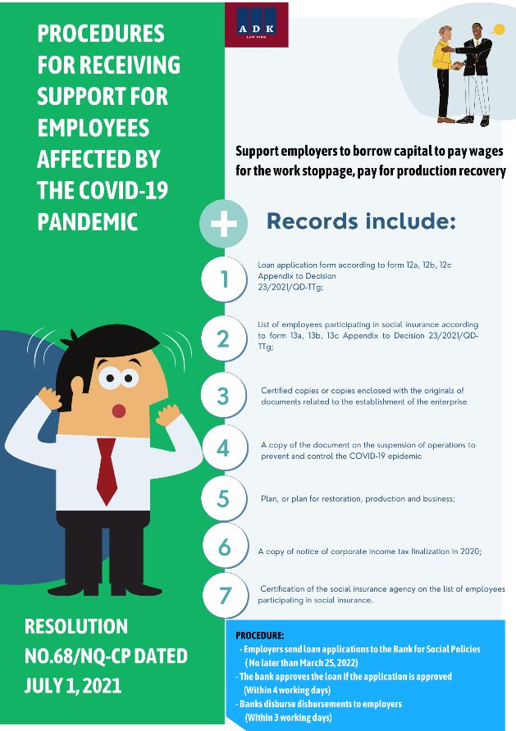 | 