Conducting a trademark search in Laos: Why and How?
Conducting a trademark search in Laos
Conducting a trademark search in Laos

1. Why should a trademark search be conducted in Laos?

Before filing a trademark application in Laos, it is advisable to conduct a search based on the trademark database of the Department of Intellectual Property of Laos (DIP) to determine the registrability of a proposed mark. Conducting a pre-filing trademark search is highly recommended for several reasons:

- Avoid potential trademark infringement: A trademark search conducted before filing a trademark application in Laos might help uncover any existing marks that may be similar to the one you intend to register. This can help you avoid infringing on the trademark rights of others and prevent costly legal disputes down the road.

- Save time and resources: If a pre-filing trademark search reveals that your proposed trademark is already taken, you can avoid the time and expense of preparing and filing a trademark application that is likely to be rejected.

- Improve chances of success: A pre-filing trademark search can help you determine the chances of successfully registering your trademark. This can help you identify any potential obstacles or objections that may arise during the application process, allowing you to address them before filing your application.

- Increase market awareness: You can gain valuable insights into the types of products and services offered under similar trademarks through a pre-filing trademark search. This information can help you make informed decisions about your business strategy and avoid potential problems in the future.

- Know about the strenght of the proposed mark: The strength of a trademark refers to its ability to identify and distinguish the goods or services of one party from those of others. The stronger a trademark, the more likely it is to be granted trademark registration and provide the owner with a greater degree of protection. If the search reveals that there are already many similar trademarks in use, it may indicate that your proposed mark is weak and may not be easily distinguishable from others. On the other hand, if your proposed mark appears to be unique and not too similar to existing trademarks, it may be considered strong.

2. How to conduct a trademark search in Laos?

You can conduct a trademark search based on the online trademark database or you may request the Department of Intellectual Property of Laos for conducting an official trademark search.

2.1. How to conduct an online trademark search in Laos?

The Department of Intellectual Property of Laos does not have an online trademark database that is publicly accessible for conducting trademark searches. However, the trademark database of Laos and many other countries have been included in the WIPO’s platform (WIPO Monitor). You can conduct an availablity trademark search at the following websites:

- <https://www3.wipo.int/madrid/monitor/en/>

- <https://legacy.branddb.wipo.int/branddb/en/index.jsp>

Here is a step-by-step guide on how to conduct a trademark search in Laos using the WIPO (World Intellectual Property Organization) Monitor platform:

- Go to the WIPO Monitor website: Open your web browser and navigate to the above websites.

- Select the search criteria: Type your trademark to the search field “trademark”, the class of goods/services in the search field “Nice”.

- Select the jurisdiction: At the search field “Designated contracting party”, please choose “LA” which is the abbreviation of “Lao’s People Democratic Republic”.

- Perform the search: Click the "Search" button to initiate the search. The results will show you trademarks that are similar to your proposed trademark.
Conducting a trademark search in Laos

- Review the search results: Review the search results to identify any existing trademarks that are similar to your proposed trademark. Pay attention to trademarks that have the same or similar name, logo, or design, or that cover the same or similar goods or services.

- Analyze the results: Analyze the search results to determine the likelihood of your proposed trademark being accepted for registration. Consider the similarity of your proposed trademark to existing trademarks and the strength of these existing trademarks.

Please see a screenshot when you would like to conduct a trademark search for “AMWAY” in Class 03 in Laos as an example below:

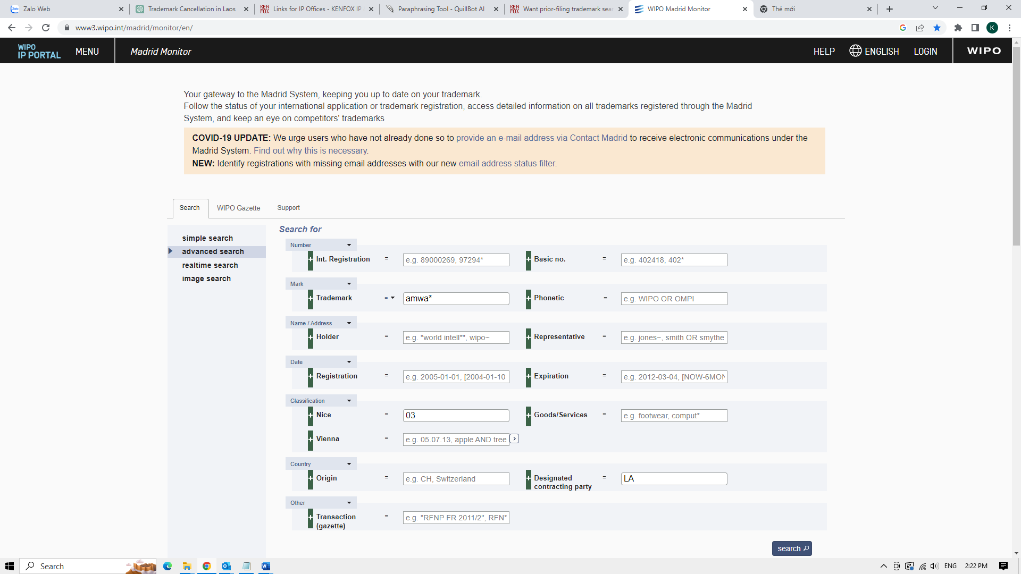
Critical notes:

- Search accuracy: While WIPO's trademark database is a valuable resource, it is important to keep in mind that the information it contains may not always be up-to-date or complete. Therefore, even if the search outcome does not provide any similar marks, it does not mean that your proposed mark is registrable. It is advisable to conduct an official trademark search. See our suggestion below.

- Trademark classifications: Trademarks are categorized into different classes according to the goods or services they are used to identify. Be sure to consider the classifications of both your proposed trademark and any similar trademarks you find during your search.

- Likelihood of confusion: The purpose of a trademark search is to determine if your proposed trademark is similar to any existing trademarks. If you find a similar trademark, consider the likelihood of confusion between the two marks. The higher the likelihood of confusion, the less likely it is that your proposed trademark will be accepted for registration

<2> How to conduct an official trademark search in Laos?

You may request the Department of Intellectual Property of Laos (DIP) for conducting an official trademark search. DIP is responsible for maintaining the trademark register in Laos.

Involved costs: It may cost over USD 100.
Timeline: An official trademark seach may be available within 15-20 working days and

When DIP receives a trademark search request, an examiner will be appointed/assigned to conduct an official trademark search to determine the availability of the proposed trademark. The following is a general overview of the steps an examiner may take to conduct a trademark search:
Conducting a trademark search in Laos

- Review of trademark database: A responsible examiner will be appointed by DIP to conduct a search of DIP’s trademark database to determine if the proposed trademark is identical or confusingly similar to any existing trademarks that have been registered or are pending registration. The trademark database includes information on trademarks that have been filed, registered, or abandoned, and the examiner will review this database to see if the proposed trademark conflicts with any existing marks.

- Comparison of the proposed mark with existing marks: DIP’s examiner will compare the proposed trademark with the existing trademarks found in the database. If the examiner determines that the proposed trademark is confusingly similar to an existing trademark, DIP may take this mark as a citation to give a conclusion that the proposed mark is not available for registration.

- Consideration of other relevant factors: Finally, the examiner may consider any other relevant factors that could impact the registrability of the proposed trademark, such as whether it is a generic term, whether it is descriptive or suggestive, or whether it is a well-known trademark in a different jurisdiction, etc.

Below is an official trademark search issued by DIP for your reference.

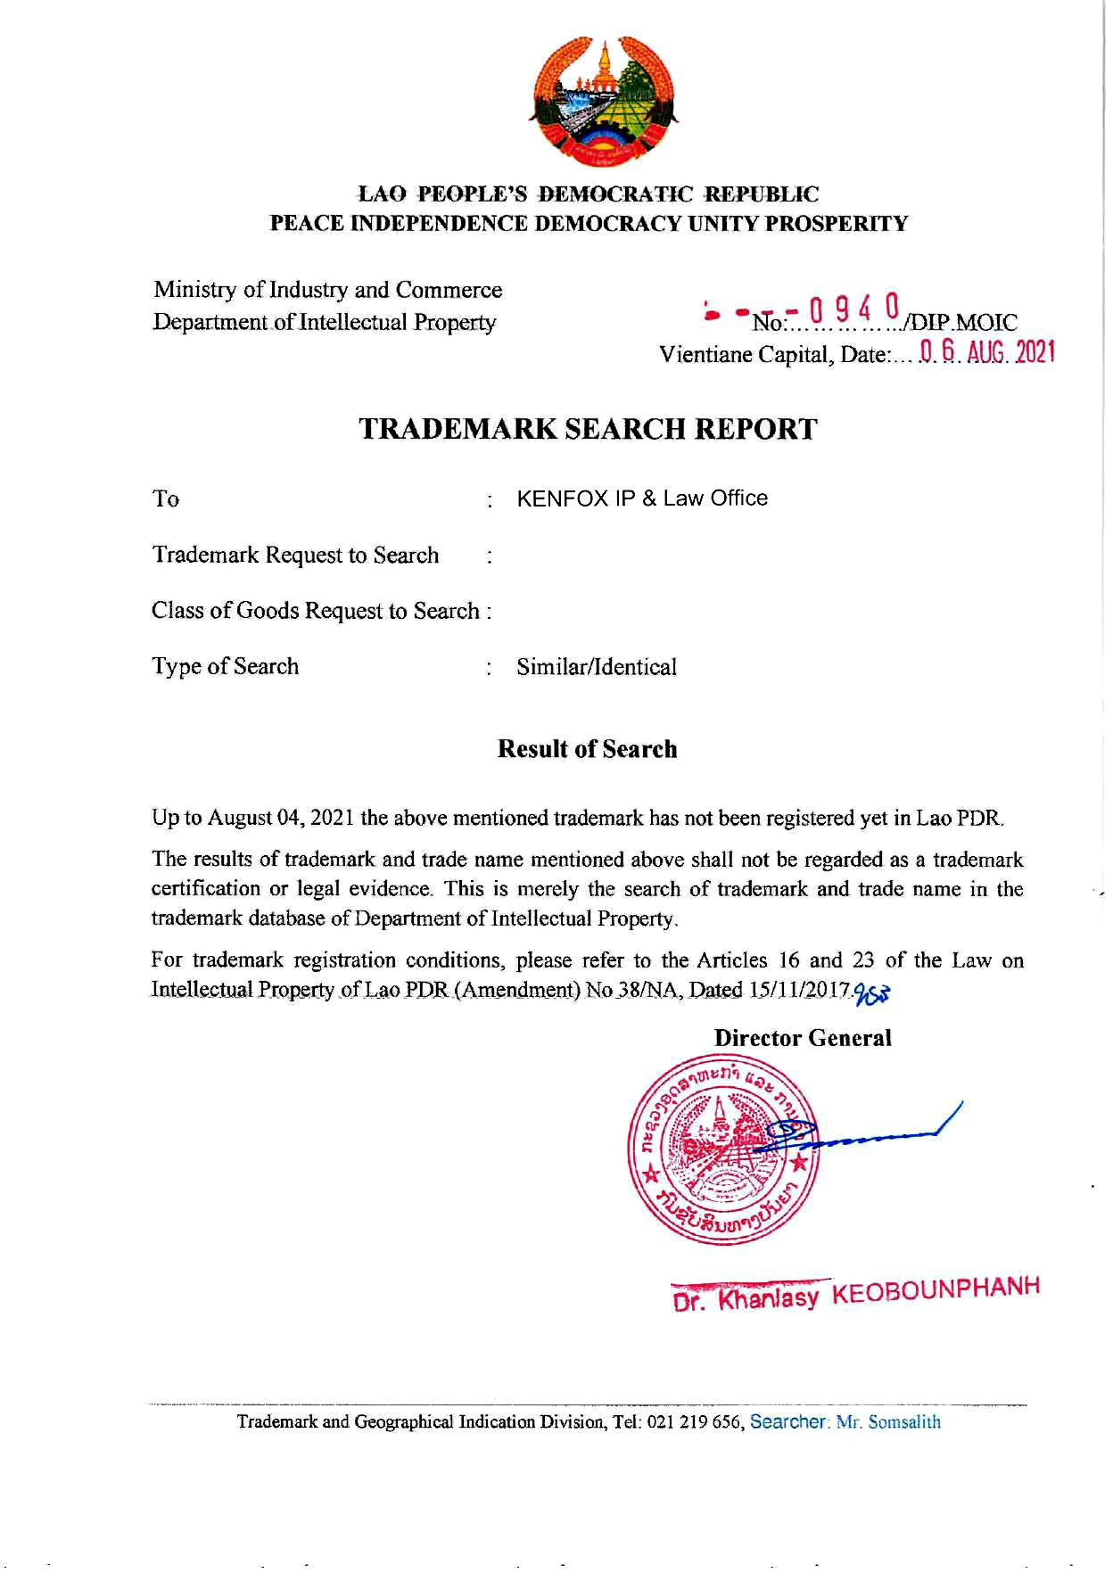
Critical notes:
Conducting a trademark search in Laos

DIP’s official trademark search report is generally considered a reliable source of information about the availability of the proposed trademarks subject to the search in Laos. The search report is based on a comprehensive review of the trademark register and other relevant sources of information, and it is produced by trained examiners who are knowledgeable about trademark law and practice in the country.

However, it is important to note that DIP trademark search report should be deemed only a preliminary assessment of the availability of a trademark and it is not a guarantee that the proposed trademark will be approved for registration. The following notes should be taken into account:

- A preliminary assessment: The trademark search report is not a guarantee that the proposed trademark will be approved for registration. It is simply a preliminary assessment of the availability of the trademark based on the information available to the IP Office at the time the search was conducted.

- Limited scope: The trademark search report may not cover all relevant trademarks, and it may not reflect the most up-to-date information.

- Focus on registrability: The trademark search report is focused on determining the registrability of trademarks, not the enforceability of trademark rights. Even if a trademark is approved for registration, it may still infringe the rights of others, or it may be vulnerable to challenge in the future, e.g. a well-known trademark for the goods/services other than those bearing your proposed trademark.

In conclusion, the official trademark search report issued by DIP can be a useful tool for evaluating the availability of a proposed trademark, but it should not be totally relied upon as the sole source of information.

By Nguyen Vu QUAN
Partner & IP Attorney
Contact
KENFOX IP & Law Office
Building No. 6, Lane 12/93, Chinh Kinh Street, Nhan Chinh Ward, Thanh Xuan District, Hanoi, Vietnam
Tel: +84 24 3724 5656
Email: info@kenfoxlaw.com / kenfox@kenfoxlaw.com

